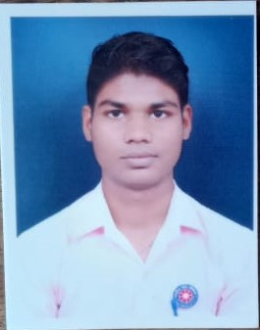
Mr.Bhupendra Sahu
J.B.S (Faculty)
Department of History
Govt.L.C.S. College Ambagarh Chowki
Mobile No.9399009753
Email id.bhupendrakumar4615@gmail.com

Current Position : J.B.S. At Department of History, Govt.L.C.S.College Ambagarh Chowki Since 2022.
Educational Qualification
- Bachelor of A From Govt.Hemchand Yadav University Durg 2020
- Master Of Science From Govt.Hemchand yadav University Durg 2022

