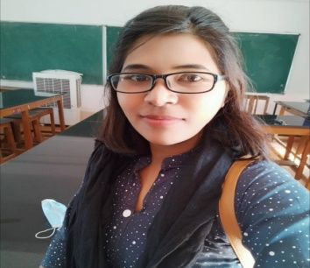

Miss Revantin patiyare
J.B.S (Faculty)
Department of Botany
Govt.L.C.S. College Ambagarh Chowki
Mobile No.6263445096
Email id.revantin01081997@gmail.com

Current Position : J.B.S. At Department of Botany, Govt.L.C.S.College Ambagarh Chowki Since 2022.
Educational Qualification
- Bachelor of science From Govt.Hemchand Yadav University Durg 2018

- Master Of Science From Govt.Hemchand yadav University Durg 2020

