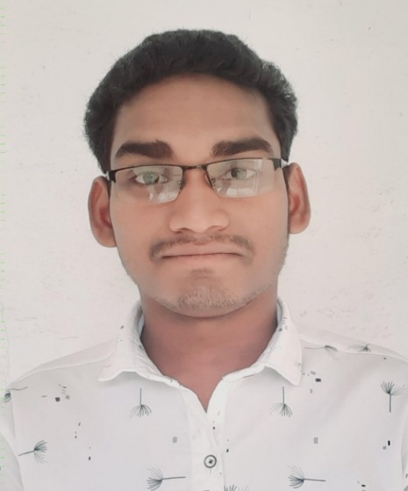
RAJENDRA KUMAR KHARE
(J.B.S lecturer)
Department of sociology
Govt. L.C.S college ambagarh chowki
Mo. – 7067130748
Email- kharer387@gmail.com

Current position: JBS LECTURER at Department of sociology Govt. L.C.S. College Ambagarh chowki since September 2022.

Qualification
- CG SET-19
- Master of arts (Hemchand yadav University durg, C.G.)
- Bechelor of arts (Hemchand yadav University durg, C.G.)

