Curriculum Vitae
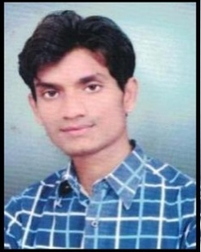
Name – Sumit Agrawal
Father’s Name – Mr. Omprakash Agrawal
Mother’s Name – Mrs. Santosh Bai Agrawal
Date of Birth – 19-03-1993
Aadhar No. – 855016717415
Mo. No. – 9893177573
Email id – asumit074@gmail.com
Address – Ward No 06 Sewtapara Dongargaon Distt. - Rajnandgaon (C.G.)
Education:-
* M.Sc (Botany) (2017) - Pt. Ravishankar Shukla University Raipur
* B.Sc (Bio) (2015) - Pt. Ravishankar Shukla University Raipur
* 12^{th (}Bio) (2012) - Cgbsc Raipur
* 10th (2010) - Cgbse Raipur

Academic Experience :-
YEAR 2022:- As J.B.S. Teacher Govt. L.C.S. College Ambagarh Chwoki ( C.G.)
YEAR 2021:- Guest Lecture Govt. L.C.S. College Ambagarh Chwoki ( C.G.)
YEAR 2020:- Guest Lecture Govt. L.C.S. College Ambagarh Chwoki ( C.G.)
YEAR 2019:- Guest Lecture Govt. L.C.S. College Ambagarh Chwoki ( C.G.)
YEAR 2018:- Guest Lecture Govt. L.C.S. College Ambagarh Chwoki ( C.G.)
Technical’s Skills:-
Anatomy of roots, Anatomy of stem
Description of plant
Algae fungi, Bryophyta, Pteridophyta
Gymnosperm, plant tissue culture technique
Achievement:-
Gold Medal (M.sc Botany)
Gold Medal (2nd Year)
President of Botany Department
Vice President of Govt. B.S.B.A College Dongargaon
NSS C-Certificate
Conference Seminar – 2 (in Botany Subject)

Reference:-
Dr. J.P. Suryawanshi

