Govt. Lal Chakradhar Shah College, Ambagarh Chowki (C.G.)
Session :- 2021-22
Best Practice :-
- Community Service –
- Objective of the Practice :- To create sense of Social service in students and people by undertaking various social activities. Propagation of govt.'s welfare schemes through NSS, NCC units of the college is also one of major Social sectors

- Context :- College is situated in semi-urban trible area. In this area people have lack of knowledge of welfare schemes initiated by govt. for vulnerable sections of society. They also lack in resources . So college organizes continuously social awareness programs . Apart from this there is want of public stalls to quench their thirst. Travellers generally miss clean drinking water points during summer. So College raises water serving point for people through NCC, NSS units of the college.

- Practice – College raised water serving point for people during summer through NCC, NSS unit of the college. NCC cadets and NSS volunteers served continuously on rotation basis . College continuously organizes awareness programs on SVEEP, HIV , human rights , vaccination, plantation, propagation of govt. welfare schemes etc.

- Evidence :-

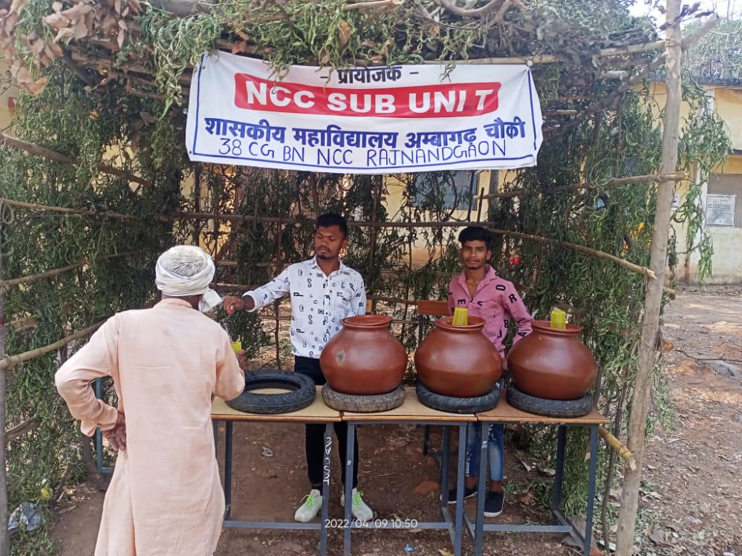
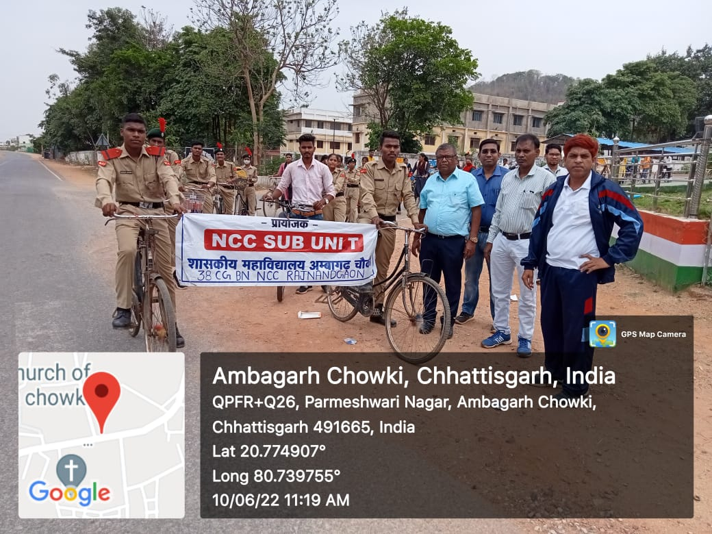

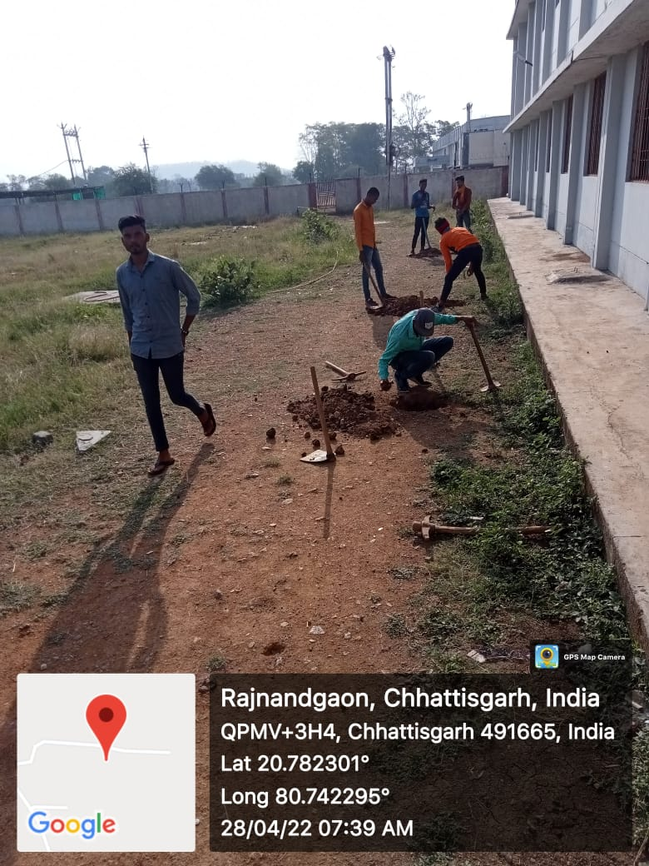

- Blood Donation and Health awareness :-

- bjective of the Practice :- To Promote blood donation and health awareness in students and people.

- Context :- In this area people have blind faith about blood donation and health . So Govt . L. C. S. college continuously organizes Blood donation camp and health awareness programs . In such programs people are made aware about importance of blood donation , and how to promote health .

- Practice :- Govt . LCS College Ambagarh Chowki , Govt. Medical College Rajnandgaon and Rakt Dan Mahadan Samiti Ambagarh combined organized blood donation and health awareness program on 25/08/2021. In this program many people including college students donated blood

