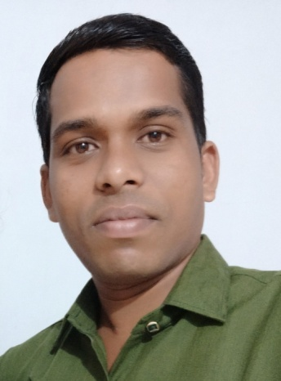

**Mr. S.K. Dewangan**

**Assistant professor(Mathematics)**

**Govt.LCS College, Ambagarh Chowki**

**Phone: 9926662284**

**Email:** [**somdew1947@gmail.com**](mailto:somdew1947@gmail.com)

**Qualification:**

* **CGSET. (Chhattisgarh VyavsaikPariksha Mandal, Raipur)**
* **Master of science- Mathematics (PSSOU, Bilaspur)**
* **Bachelor of science (PRSU , Raipur)**

**Area of Interest/ Specialization:**

* Algebra & Trigonometry
* Calculus
* Complex numbers
* Differential equations

**Work experience**

* **Assistant professor since 0/10/2022 at Govt. L.C.S. College Ambagarhchowki**
* **As a school lecturer 5 years experience . 2017 to2022**
* **As a middle school teacher 4 years experience . 2013 to 2017**
* **As a primary school teacher 3 years experience . 2010 to 2013**